Technical Bulletin
Proper Routing of Charge Cables into an X-Series Pack

This bulletin is to notify users of all Flux Power X-series batteries, that there is a proper way to route their charge cables to prevent damage to the charge port in their batteries.

Batteries Affected
All X-series batteries that have Part Number 100160-XX, 100165-XX, 100166-XX, 100167-XX, 100168-XX & 10034X-XX may be affected. Please look at the picture below showing a pack data label and where you can find the item number:

Identifying the Issue
We have observed that Stanbury chargers equipped with a retractor or spring pole, preventing the cables from laying on the floor, have caused stress on the charge port. This stress prevents a good connection between the charger and the battery during charge. This leads to a rise in temperature at the connection which eventually starts to melt the A320 connector and open up the female pins on the charge port of the battery pack. We propose the following solution for the charge cables so they don’t put unnecessary stress on the charge port.
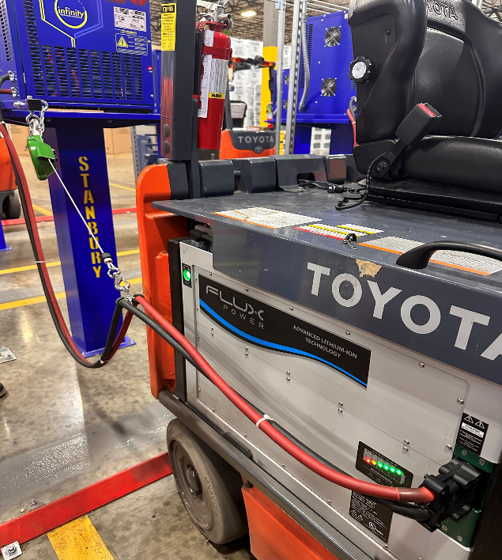
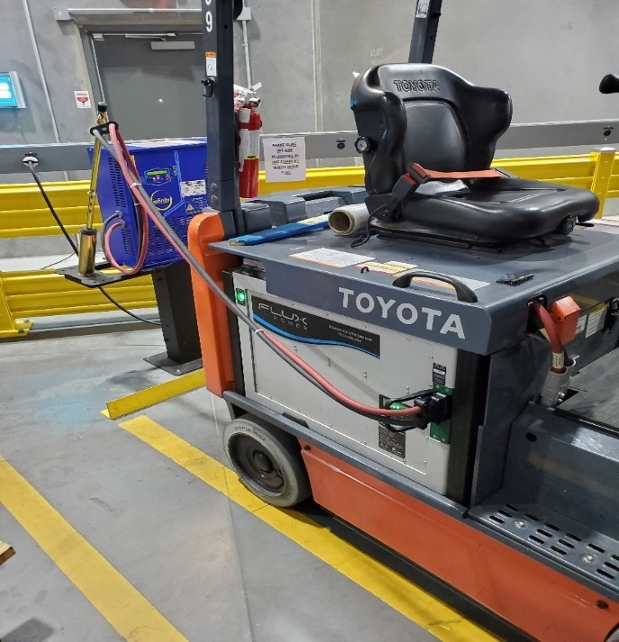

Point of stress on the charge connector

Example of a Stanbury Charger with a retractor Example of Stanbury with a spring pole

Proposed Solution
We recommend the installation of two P-clips and an eyehole screw 4ft away from the A320 connector on your Stanbury charger. You can add a rope hook to your truck so you can hang the cables while charging your battery pack. This solution shifts the weight of the cables and the stress created by the retractor or spring pole, from the charge port to the truck’s chassis. It provides slack at the charge port which prevents further damage due to stress at the connection. The solution is illustrated below:

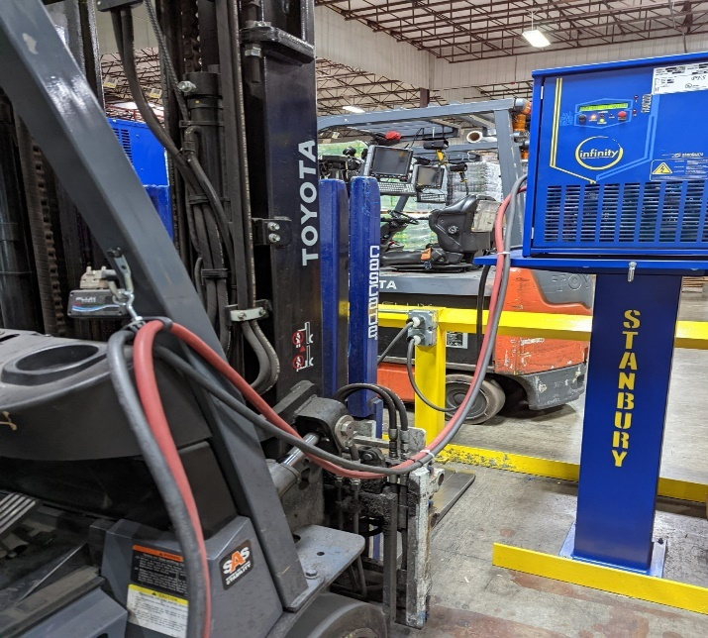
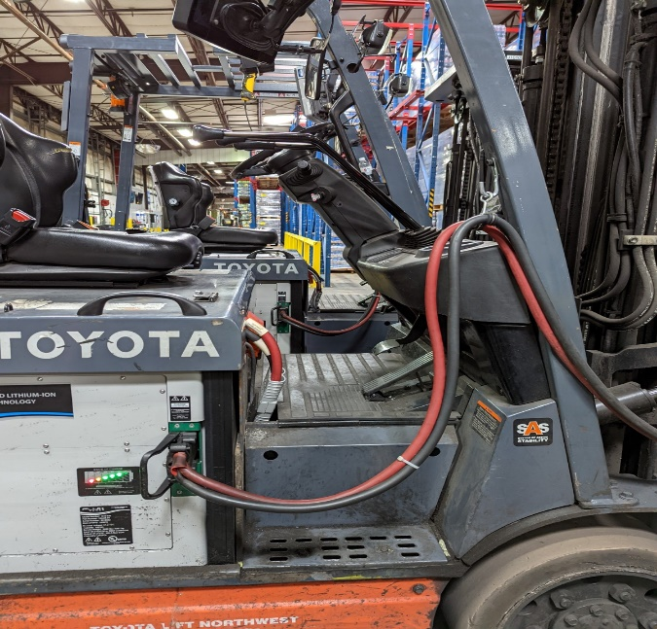

You can install another rope hook next to the charger so you can hang the cables after the charge and this way they aren’t laying on the floor. For reference, please look at the pictures below:

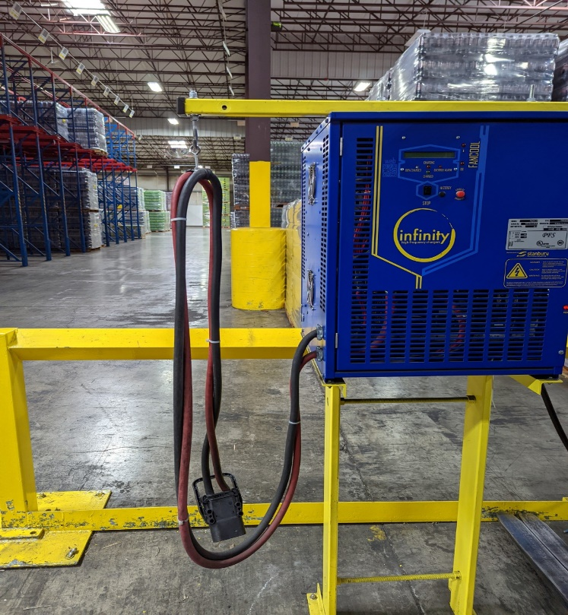

Any Damage to the battery’s charge port resulting from the stress created at the charge port connector due to a retractor or spring pole, will not be covered under warranty.

Flux Power Contact Details
Flux Power, Inc.
Address: 2685 South Melrose Drive,
Vista, CA 92081
Tel: 877-505-3589 Option 1
Email: Support@fluxpower.com
Web: www.fluxpower.com

Copyright ©2023 Flux Power, Inc. All rights reserved. Flux Power, the Flux Power Logo, and Flux Power LiFT Pack are registered trademarks or trademarks of Flux Power, Inc. All other brands and product names are trademarks or registered trademarks of their respective owners. This information is intended for the use of Flux Power customers only. Any other use without the express written consent of Flux Power, Inc. is strictly prohibited.

