FLUX Power LiFT Pack M24 New Generation

Service and Parts Manual

WARNING – Risk of Fire – No User Serviceable Parts

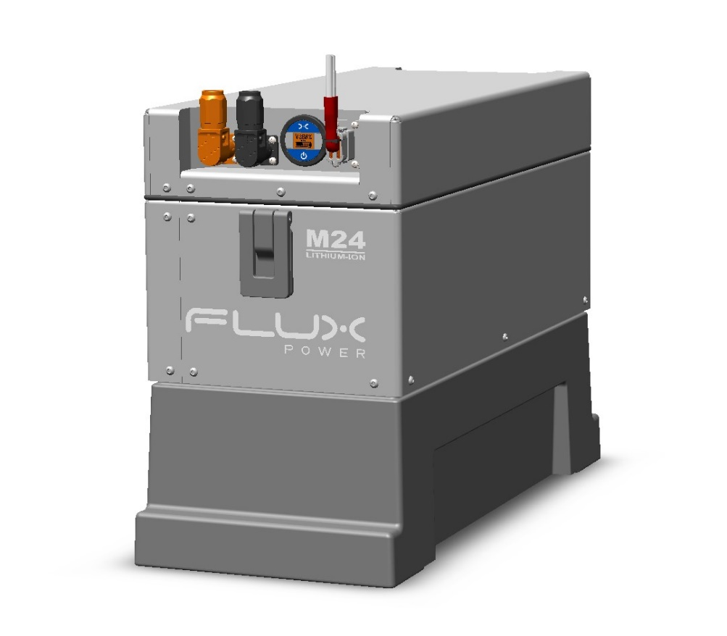

**Safety Precautions**

The FLUX Power Lithium-ion Battery is composed of lithium-ion cells and is classified as Class 9 miscellaneous hazardous material.

Precautions to correctly handle the FLUX Power Lithium-ion Battery include:

* The battery shall only be handled by FLUX Power authorized personnel familiar with handling, storing, and the installation of a lithium-ion battery.
* Do not open the battery. – Only FLUX Power authorized technicians shall perform service on a lithium-ion battery.
* Do not tamper with the main power Anderson connector.
* Do not mount or store the battery upside down or on its side.
* Upon receipt, check the battery for damage during transportation.
* Always use a lifting device when installing a battery.
* Never recycle lithium-ion batteries with lead-acid batteries, please consult FLUX Power or your local recycler for more information on how to recycle a Lithium-ion Battery.
* WARNING – Risk of Fire – No User Serviceable Parts
* 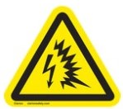 Consider all DC battery cells and circuits to be energized, shorting of circuits may cause a hazardous condition. Remove all metallic jewelry from hands and arms before working on battery cells or circuits.
*  SAFETY - Follow Safety Standards as required; review and follow all Safety Data Sheets “SDS” for chemical use. Follow instructions for the proper use of PPE as required.

For technical assistance on the FLUX Power Lithium-ion Battery, contact your local FLUX Power dealer at [www.Fluxpower.com](http://www.fluxpower.com).

Table of Contents

1. Introduction 5
2. Basic Troubleshooting 5

2.1 Flux Power Battery Control of Hazardous Energy Procedure 5

2.2 Battery Discharge Indicator (BDI) and Device Trouble Codes (DTCs) 6

2.3 Temperature (DTC 2) 7

2.5 No Lights on BDI, No Power to Truck 7

2.6 Overdischarged 8

1. Safety and Reliability 9

3.1 Hazardous Material Information 9

3.2 What to do if a Cell Breach Occurs 10

3.3 Heavy Water Spray 10

1. Recycling/Disposal 10

4.1 Recycle 10

4.2 Re-Use 10

4.3 Disposal 10

1. Shipping Information 11
2. Parts and Tools 11

6.1 List of Service Kits 11

6.2 Tools 12

Appendix A-1: CONTACTOR SERVICE KIT 13

Appendix A-2: BMS 2.0 BOARD KIT 14

Appendix A-3: MAIN FUSE SERVICE KIT 15

Appendix A-4: SMALL FUSE SERVICE KIT 16

Appendix A-5: CAPACITOR SERVICE KIT 17

Appendix A-6: CURRENT SENSOR SERVICE KIT 18

Appendix A-7: MAIN HARNESS SERVICE KIT 19

Appendix A-8: BDI SERVICE KIT 20

Appendix A-9: COMMUNICATIONS PORT SERVICE KIT 21

Appendix A-10: POSITIVE and NEGATIVE POWER CABLE RECEPTACLES 22

Appendix A-11: POSITIVE POWER CABLE RECEPTACLE 23

Appendix A-12: NEGATIVE POWER CABLE RECEPTACLE 24

Appendix A-13: DIAGNOSTIC SERVICE KIT 25

Appendix A-14: POWER CABLES 2ft 2/0 AWG GREY SERVICE KIT 26

Appendix A-15: POWER CABLES 3ft 2/0 AWG GREY SERVICE KIT 27

Appendix A-16: POWER CABLES 4ft 2/0 AWG GREY SERVICE KIT 28

Appendix A-17: POWER CABLES 2ft 1/0 AWG GREY SERVICE KIT 29

Appendix A-18: POWER CABLES 3ft 1/0 AWG GREY SERVICE KIT 30

Appendix A-19: POWER CABLES 4ft 1/0 AWG GREY SERVICE KIT 31

Appendix A-20: POWER CABLES 2ft 1/0 AWG RED SERVICE KIT 32

Appendix A-21: POWER CABLES 3ft 1/0 AWG RED SERVICE KIT 33

Appendix A-22: POWER CABLES 4ft 1/0 AWG RED SERVICE KIT 34

1. 8 Flux Power Contact Details 35

# Introduction

The LiFT Pack M24 is a lithium-ion battery specialized for the material handling industry. This User Guide is intended to provide information on how to service a Flux Power LiFT Pack M24.

# Basic Troubleshooting

Before performing any work on the battery, make sure to follow the Control of Hazardous Energy Procedure.

## **Flux Power Battery Control of Hazardous Energy Procedure**

|  |  |  |
| --- | --- | --- |
| 1. Disconnect the DC battery cable. |  | 2. Disconnect the AC battery charger power cord. |
|  |  |  |
| 3. Locate the BDI’s push button and hold it down to turn off the battery. |  | 4. Use a DMM to test for voltage at the battery connector contacts. The voltage must be approximately zero volts. |
|  |  |  |
| 5. Install a lockout device and *“do not operate”* tag on the battery discharge connector with a lock or a nylon wire tie. Sign and date the *“do not operate”* tag. |  | 6. Install a lockout device and a *“do not operate”* tag on the AC power cord with a lock or a nylon wire tie. Sign and date the *“do not operate”* tag. |
|  |  |  |

## Battery Discharge Indicator (BDI) and Device Trouble Codes (DTCs)

The first step in troubleshooting the battery is observing the State of Charge (SOC) off of the battery’s BDI. In normal operation, the BDI will display the battery’s current state in as a percentage with no DTCs present. If a DTC is present then the BDI will indicate so with a DTC number. DTCs let the user or technician quickly assess why a battery may be disrupting operation. The following list details each DTC.

**Situations where the Flux Power lithium battery will cut power and display a DTC**

|  |  |  |  |  |  |
| --- | --- | --- | --- | --- | --- |
| **Fault Description** | **Cause and Required Duration to Trigger** | **Fault Protection** | **DTC Number** | **Service Required?** | **Fault Resolution** |
| 0% State of Charge | <5% State of Charge,  Immediate | Buzzer Sounds Periodically | 1 | No | Connect appropriate charger |
| Over-temperature | Discharge temperature > 133F, 10 seconds  Charge temperature > 115F, Immediate | Contactor opens | 2 | No | Allow pack to cool, then cycle the circuit breaker OFF, then ON |
| Under temperature | Discharge temperature < -2F, 10 seconds  Charging < -4F, Immediate | Contactor opens | 2 | No | Allow pack to warm, then cycle the circuit breaker OFF, then ON |
| High Cell | At least one cell is >3.65V, Immediate | Contactor opens | 3 | No | Cycle the battery OFF, then ON through the battery’s BDI. If fault occurred while charging, allow cells to settle |
| Current Exceeded | Discharge >-1000A, 10 seconds  Charge >1000A, 10 seconds | Contactor opens | 4 | No | Cycle the battery OFF, then ON through the battery’s BDI |
| Hardware Failure | Electronic component failure for more than 10 seconds | Contactor opens | 6 | Yes | Service |
| Low Cell | Fixed threshold of  <2.8V for cell temp >25C | Contactor opens | 9 | No | Connect the appropriate charger and cycle the battery through the battery’s BDI |
| Integrity Signal | Communications port missing loop-back or external harness issue | Contactor opens | 11 | Yes | Ensure that the communications port has a proper loop-back. If an external harness is connected then ensure that all components of the harness are properly connected and functioning. Contact Product Support if further assistance is needed |

## Temperature (DTC 2)

Flux Power lithium batteries without the heater option have an operational ambient temperature range of 0°C / 32°F to 55 ̊C / 131°F when discharging. The BMS2 will prevent operation outside these temperatures, but a heater option is available for cold storage and freezing weather applications. Batteries subjected to low temperatures (0°C / 32°F or lower) may experience decreased performance if not equipped with the heater option. A Flux Power lithium battery, without heaters, experiencing a DTC number 2 should be approached with either the following:

1. If the temperature outside the battery is cold, then the battery should be taken to a warmer environment to warm up.
2. If the temperature outside the battery is warm, then the battery should be taken to a cooler environment to cool down.

## No Lights on BDI, No Power to Truck

If there are no lights on the BDI and there is no power to the truck, it may be in storage mode. Storage mode prevents the electronics from draining the battery and increases storage time. It is recommended the battery be plugged in and fully charged every six months when being stored.

1. Check the BDI’s push button breaker. Cycle the battery by pressing the button to turn it off and again to turn it on. If the battery does not power up, continue to step 3.
2. Ensure that the battery’s communications port has the proper loop-back insert. If there are external harnesses attached to the port, ensure that these accessories are well attached. The loop back necessary will be pins 6 and 7 on the connector.
3. First remove the battery from the truck and follow the proper controls of hazardous energy. The top lid of the battery can be removed by unscrewing the X bolts on the bottom edge of the top lid all around. The top lid can latch itself onto the newly exposed top exterior of the battery through two manufactured slots off two armatures coming from underneath the top lid.
   1. Blown Fuse – There is a 3A fuse inside the battery that is in a black fuse block alongside the internal harness that connected to the back of the 12-pin connector. Check the fuses for continuity and replace if blown.
   2. BDI Signal – Ensure that the connections from the back of the BDI are securely connected. If any pins are damaged or loose then they will need to be replaced.

## Overdischarged

The battery pack contains advanced electronics which will slowly drain the battery if it is not charged up regularly. If a pack drains below 22.4V, the contactor opens. A battery with an overall voltage of 20V or less is severely overdischarged. The battery can be recovered with the use of a device equipped with the Graphical User Interface (GUI) titled Flux Connect – System Monitor 2 and PCAN drivers, and a PCAN dongle connection assembly to connect the device to the battery. These components can be seen in figure 9. Graphical user interface, text

Figure 1: PCAN dongle connection assembly

To revive a battery with these components, conduct the procedure below completely. Failure to properly carry out this procedure can damage the battery and void the warranty. Do not carry out the process without direct approval from a Flux Power Product Support representative.

1. Connect PCAN dongle to the battery’s 12-pin communication port.
2. Connect the PCAN dongle’s USB end into the laptop or tablet.
3. Turn the battery on through the push button on the BDI.
4. On the laptop or tablet, open the appropriate GUI.

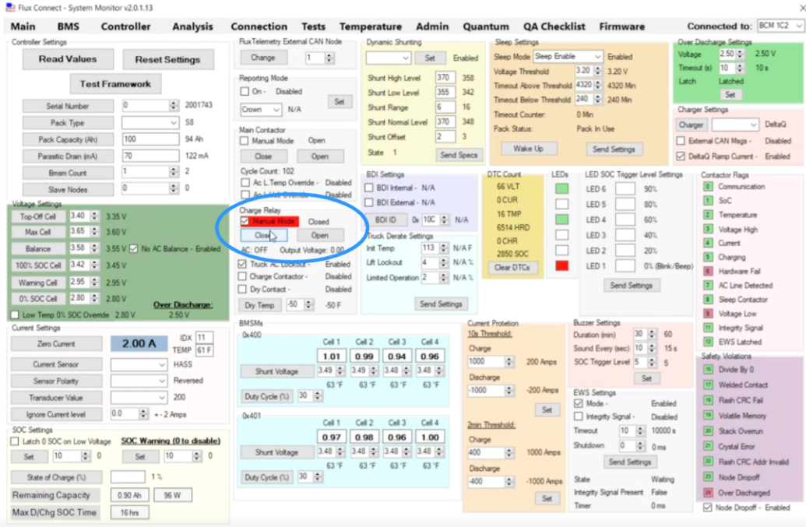

Figure 2: Location of the Charge Relay on the GUI

1. Select the Admin Tab. Under Main Contactor select the unmarked box for Manual Mode. Click on the “Close” button below that.
2. Set the external charger to 6A.
3. On the GUI, observe the current as it rises to 6A.
4. On the Admin Tab, ensure that all cells increase together up to 3.2V. The cells should each reach this voltage value within one hour. If the cells do not reach this voltage value within an hour, then contact a Product Support representative.
5. On the top right of the screen under Over Discharge Settings, click on the “Set” button.
6. Once all 8 cell voltages reach past 3.2V, then uncheck the box for Manual Mode under Main Contactor. The charge current on the external charger can now be changed to a continuous value of 250A or lower.

# Safety and Reliability

Flux Power LiFT Packs are completely sealed and require no watering. No electrolyte must be added and there is no danger of acid spills or explosive vapors during normal use. In addition, the Flux Power LiFT Pack M24 is designed to pass the UL 2580 standard.

* **WARNING:** Do Not Disconnect the Anderson cable connector under load.
* Not Suitable for water exposure.
* Not intended for use in a marine environment.
* For indoor use only.
* ALWAYS use proper lifting techniques and equipment when installing the battery.
* The battery does not require regular maintenance but should be plugged in overnight once per week to allow the cells to balance.
* Do NOT attempt to open the battery, unless authorized by a Flux Power representative.
* Do NOT tamper with the main power Anderson connector.

## Hazardous Material Information

Lithium-ion batteries are considered HazMat Class 9 - Miscellaneous. There are no reporting regulations required for Flux Power LiFT Packs federally (specifically under the Resource Conservation and Recovery Act of 1976 (RCRA) and the Emergency Planning and Community Right-to-Know Act (EPCRA)). There are hazmat regulations when shipping lithium-ion batteries.

There are sometimes state or city regulations which differ from federal law, however generally speaking, a Flux Power LiFT Pack M24 under normal use has no danger of leakage, spilling, outgassing, or presenting any danger to the end user. Federal regulations are very strict when dealing with lead-acid batteries due to the environmental impacts of heavy metals (lead) and inherent dangers present: acid spills, explosive gases, and lead poisoning.

For more information on local regulations, contact your local EPA and fire department or contact FLUX Power and we will do our best to assist you.

## What to do if a Cell Breach Occurs

If a cell breach occurs open the doors and windows to allow ventilation. Do not use water to clean up the electrolyte, but instead use absorbent material. Place the contaminated rags in a metal bin. Avoid breathing the fumes, and in case of fire, do not use water, use a type D, CO2, Dry Chemical or foam fire extinguisher. For more information contact Flux Power or refer to the Safety Data Sheet (SDS). The SDS is available on the Flux Power website at www.fluxpower.com.

The damaged pack and cleaning materials should be placed in a sealed plastic or steel container and disposed of or recycled using the measures required by your local EPA.

## Heavy Water Spray

The Flux Power LiFT Pack M24 should not be used in equipment where there is excessive water spray, such as applications that require power washing. The pack should also never be submerged in water. In the event that a LiFT Pack M24 is submerged, please do not attempt to use, or charge the pack. Please contact Flux Power Technical Support at 877-505-3589.

# Recycling/Disposal

## Recycle

Lithium-ion batteries are recyclable and there are lithium-ion recycling plants nationwide. ***Do not*** *include lithium-ion batteries in shipments of lead-acid batteries being sent for recycling.*  Sending a lithium-ion battery to a lead-acid recycler could cause damage to equipment and personnel. Contact Flux Power if you need assistance. If you are unable to locate a lithium-ion recycler in your area, Flux Power agrees to take back any battery that is at its end of life.

## Re-Use

When a LiFT Pack M24 no longer holds enough charge, there are already a number of options, such as:

* Cells can be deployed into alternate second life usage, such as grid storage or emergency power.
* The steel case and electronics can be refurbished into a new pack or be recycled.

## Disposal

Flux Power is committed to the environment. Lithium-ion batteries are not specifically discussed in the Federal Resource Conservation and Recovery Act (RCRA). However, given the federal requirements for hazardous materials, a *completely discharged lithium iron phosphate cell is considered* ***non-hazardous*** *material*. States and cities may have more stringent regulations in place, some of which blanket all lithium-ion batteries as hazardous waste, while others classify them as normal waste. The Flux Power LiFT Pack M24 End of Life Guide and Guarantee ensures full compliance with laws and the highest environmental standards. The guide is available on the Flux Power website at [www.fluxpower.com](http://www.fluxpower.com).

# Shipping Information

When shipping Flux Power LiFT Packs, the products are classified as *UN 3480 Dangerous goods - Part II - Class 9 (miscellaneous)* and can only be shipped ground. The battery must be secured to a pallet or in a wooden crate. There must be nonconductive material between multiple batteries, and they cannot be stacked. If it is being shipped in equipment it must be securely installed and protected against heat, short circuit, movement, and accidental activation of the equipment. Shipping declarations, hazmat shipping documentation, and hazmat shipping training are all required. Please see the *Flux Power LiFT Pack Shipping and Reporting Guide* for more information. It is the responsibility of the shipper to obey all regulations when shipping a Flux Power LiFT Pack M24.

This guide is available on the Flux Power website at [www.fluxpower.com](http://www.fluxpower.com).

# Parts and Tools

## List of Service Kits

|  |  |  |  |
| --- | --- | --- | --- |
| **Part No.** | **Part Name** | **Appendix** | **Page No.** |
| 131145 | CONTACTOR SERVICE KIT | A-1 | 13 |
| 131146 | BMS 2.0 BOARD KIT | A-2 | 14 |
| 131147 | MAIN FUSE SERVICE KIT | A-3 | 15 |
| 131148 | SMALL FUSE SERVICE KIT | A-4 | 16 |
| 131149 | CAPACITOR SERVICE KIT | A-5 | 17 |
| 131150 | CURRENT SENSOR SERVICE KIT | A-6 | 18 |
| 131151 | MAIN HARNESS SERVICE KIT | A-7 | 19 |
| 131152 | BDI SERVICE KIT | A-8 | 20 |
| 131153 | COMMUNICATIONS PORT SERVICE KIT | A-9 | 21 |
| 131154 | POSITIVE and NEGATIVE POWER CABLE RECEPTACLES | A-10 | 22 |
| 131155 | POSITIVE POWER CABLE RECEPTACLE | A-11 | 23 |
| 131156 | NEGATIVE POWER CABLE RECEPTACLE | A-12 | 24 |
| 131157 | DIAGNOSTIC SERVICE KIT | A-13 | 25 |
| 131158 | POWER CABLES 2ft 2/0 AWG GREY SERVICE KIT | A-14 | 26 |
| 131159 | POWER CABLES 3ft 2/0 AWG GREY SERVICE KIT | A-15 | 27 |
| 131160 | POWER CABLES 4ft 2/0 AWG GREY SERVICE KIT | A-16 | 28 |
| 131161 | POWER CABLES 2ft 1/0 AWG GREY SERVICE KIT | A-17 | 29 |
| 131162 | POWER CABLES 3ft 1/0 AWG GREY SERVICE KIT | A-18 | 30 |
| 131163 | POWER CABLES 4ft 1/0 AWG GREY SERVICE KIT | A-19 | 31 |
| 131164 | POWER CABLES 2ft 1/0 AWG RED SERVICE KIT | A-20 | 32 |
| 131165 | POWER CABLES 3ft 1/0 AWG RED SERVICE KIT | A-21 | 33 |
| 131166 | POWER CABLES 4ft 1/0 AWG RED SERVICE KIT | A-22 | 34 |

## Tools

Removing the top cover of the battery:

* Screwdriver
* T27 Torx bit
* Socket Wrench
* 10mm Socket
* 13mm Socket
* 9mm Open End Wrench

Working on the electronics tray:

* Screwdriver
* Socket Wrench
* 10mm Socket
* 11mm Socket
* 13mm Socket
* 15mm Socket
* 29mm Adapter
* Cutters

## Appendix A-1: CONTACTOR SERVICE KIT

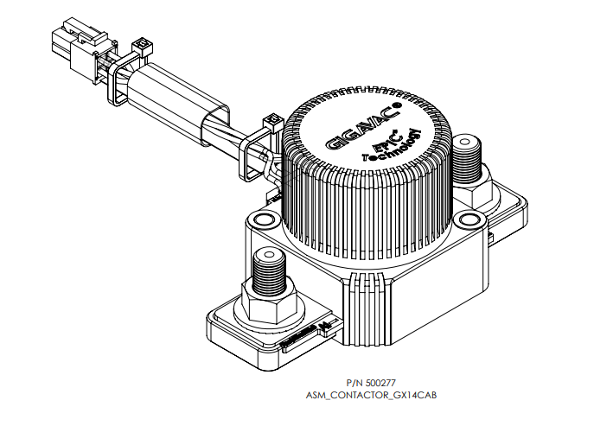

## Appendix A-2: BMS 2.0 BOARD KIT

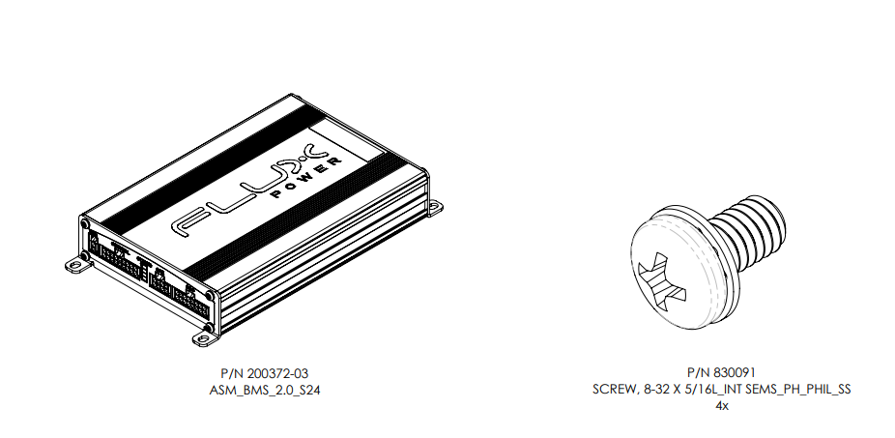

## Appendix A-3: MAIN FUSE SERVICE KIT

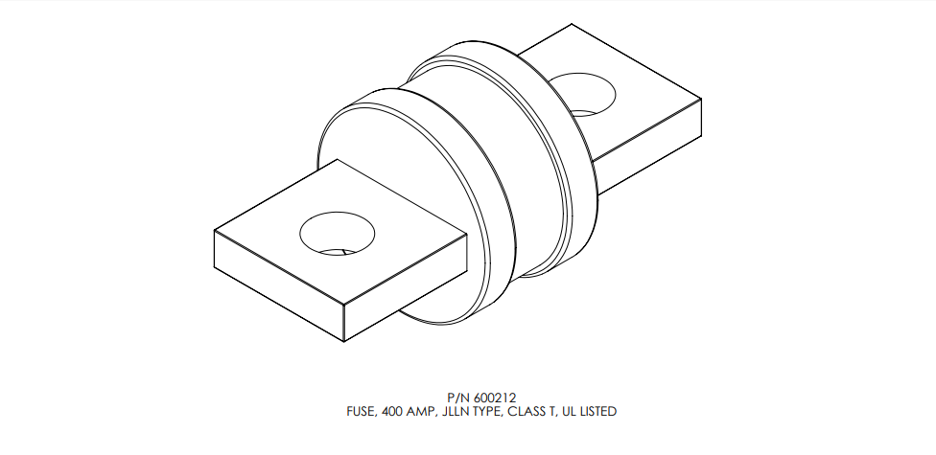

## Appendix A-4: SMALL FUSE SERVICE KIT

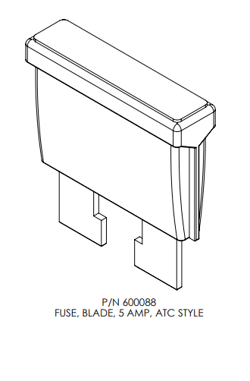

## Appendix A-5: CAPACITOR SERVICE KIT

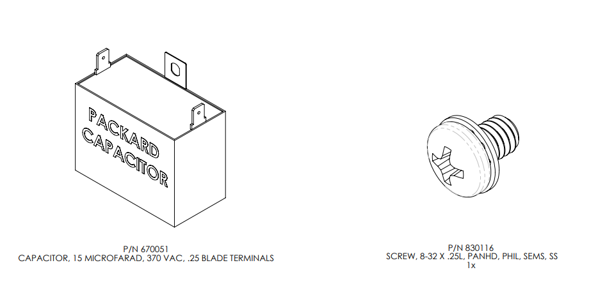

## Appendix A-6: CURRENT SENSOR SERVICE KIT

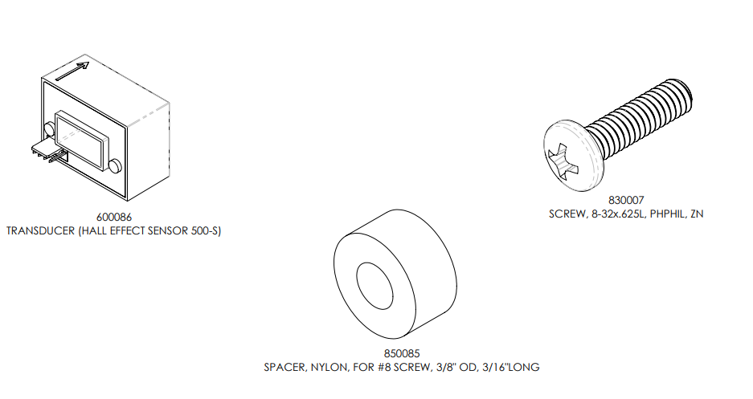

## Appendix A-7: MAIN HARNESS SERVICE KIT

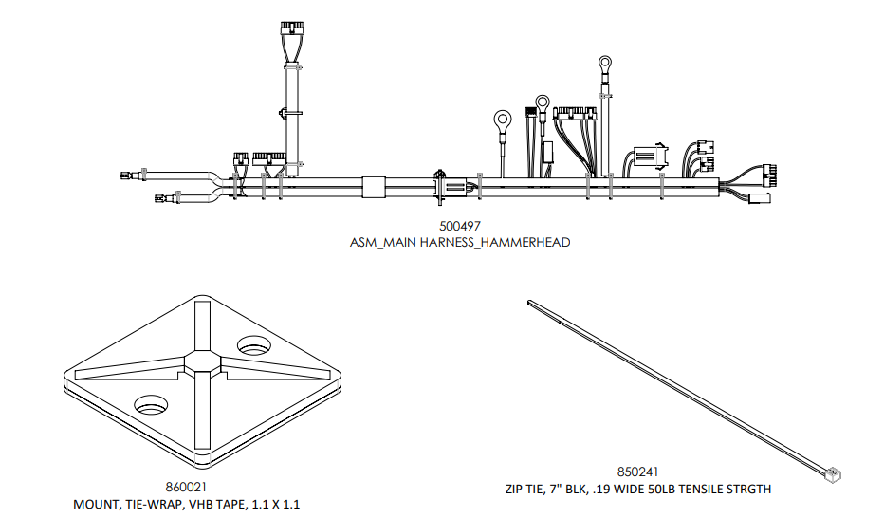

## Appendix A-8: BDI SERVICE KIT

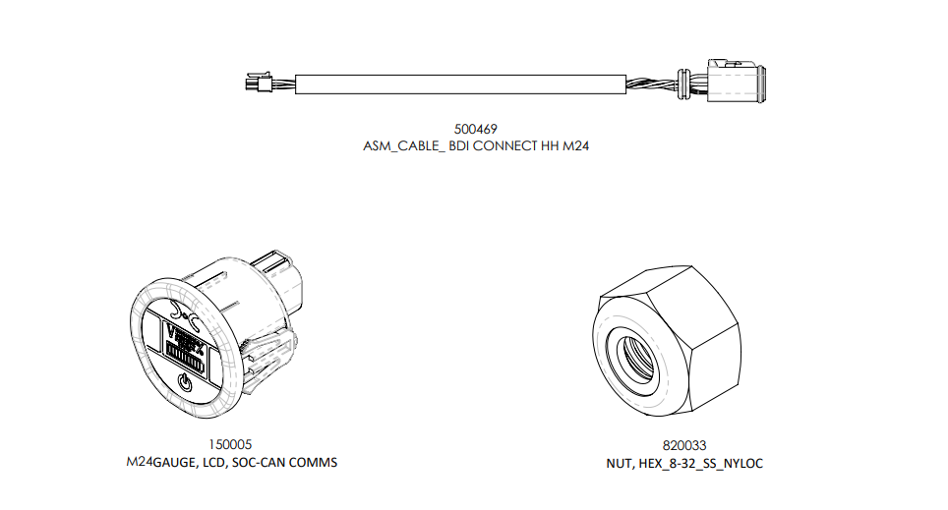

## Appendix A-9: COMMUNICATIONS PORT SERVICE KIT

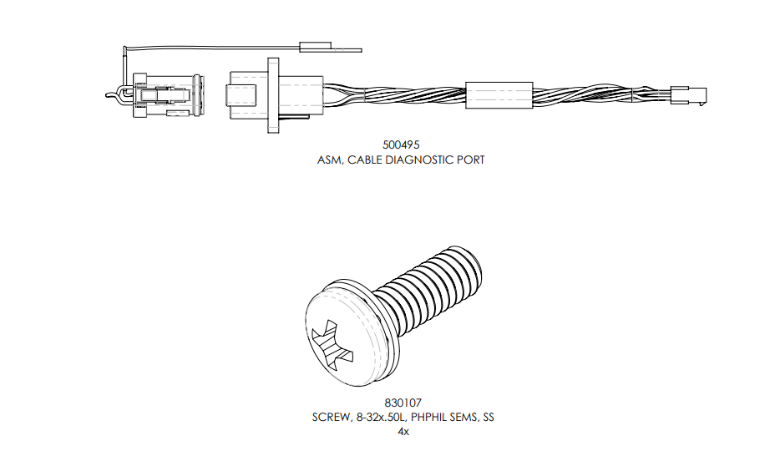

## Appendix A-10: POSITIVE and NEGATIVE POWER CABLE RECEPTACLES

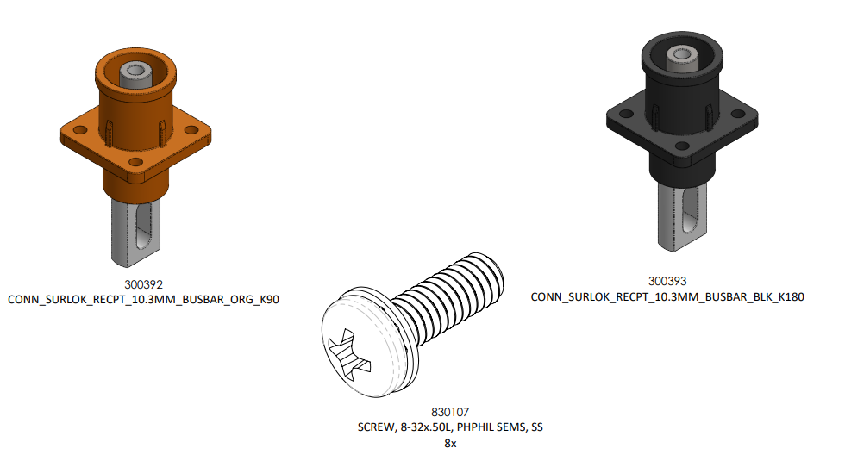

## Appendix A-11: POSITIVE POWER CABLE RECEPTACLE

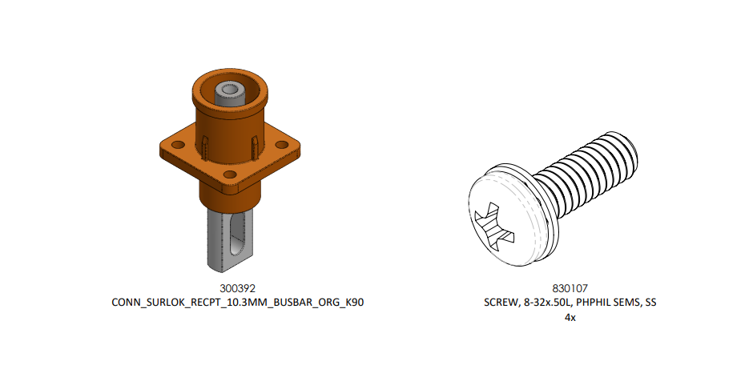

## Appendix A-12: NEGATIVE POWER CABLE RECEPTACLE

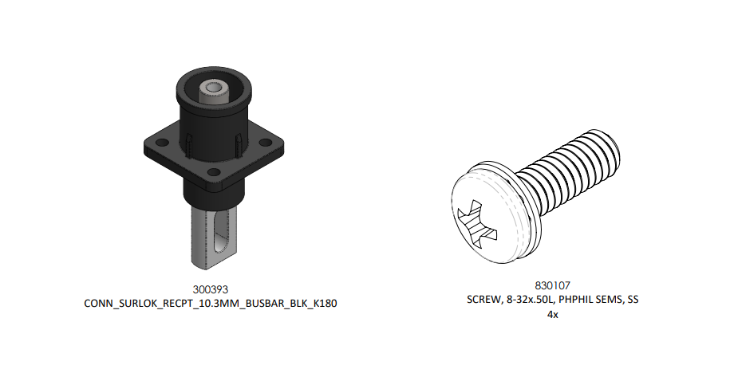

## Appendix A-13: DIAGNOSTIC SERVICE KIT

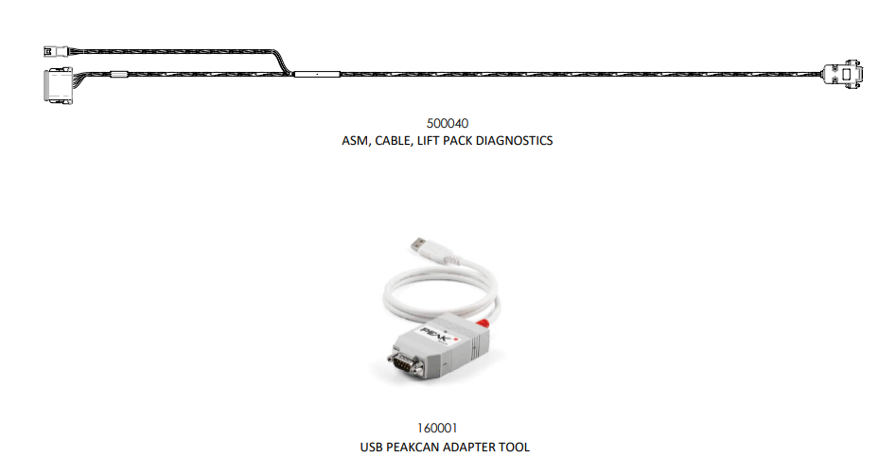

## Appendix A-14: POWER CABLES 2ft 2/0 AWG GREY SERVICE KIT

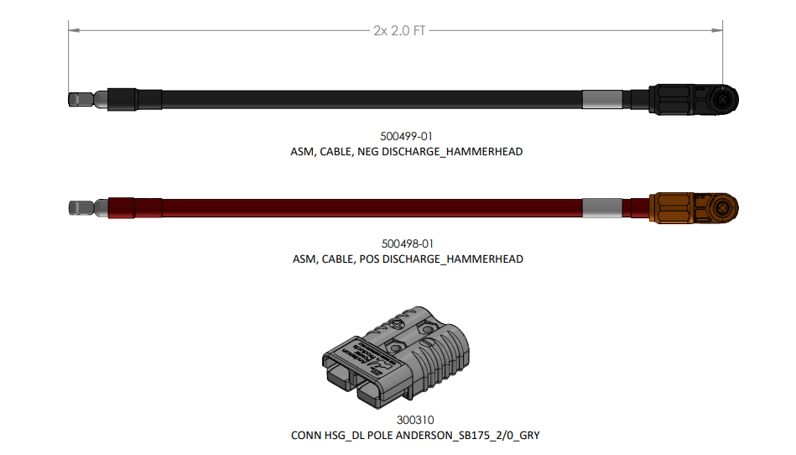

## Appendix A-15: POWER CABLES 3ft 2/0 AWG GREY SERVICE KIT

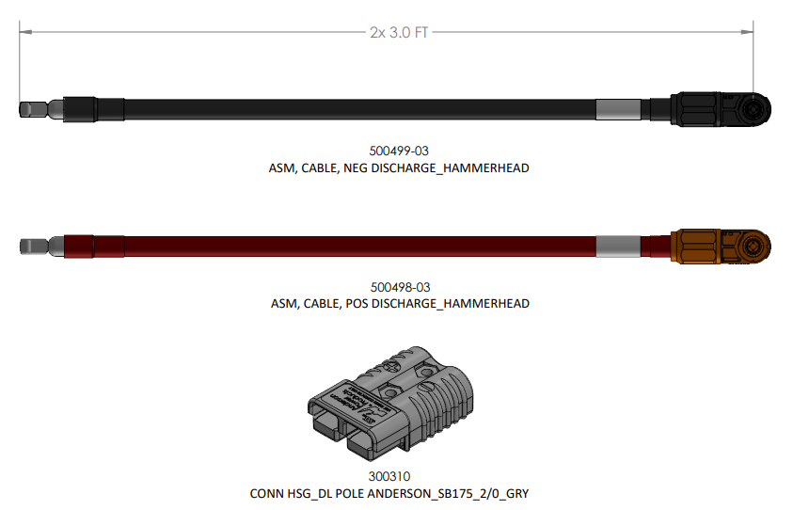

## Appendix A-16: POWER CABLES 4ft 2/0 AWG GREY SERVICE KIT

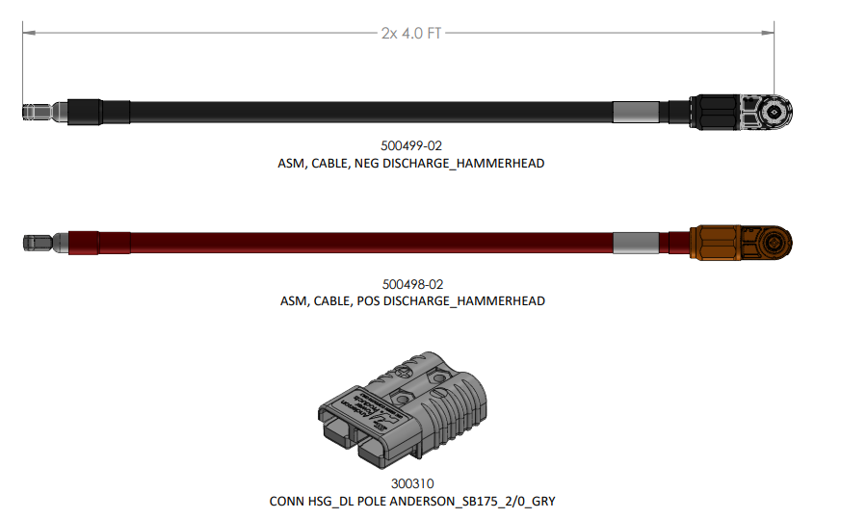

## Appendix A-17: POWER CABLES 2ft 1/0 AWG GREY SERVICE KIT

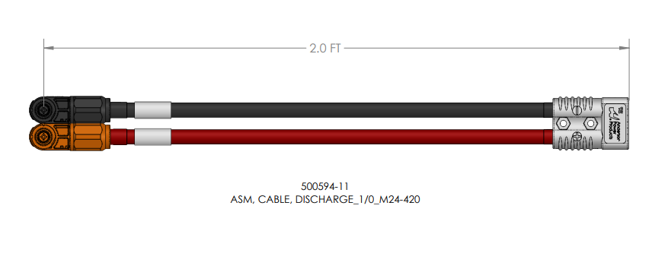

## Appendix A-18: POWER CABLES 3ft 1/0 AWG GREY SERVICE KIT

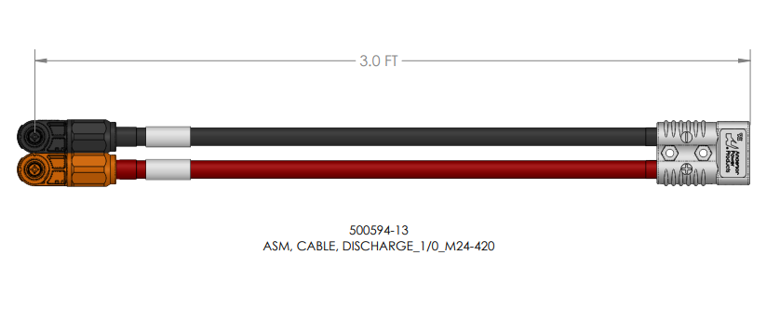

## Appendix A-19: POWER CABLES 4ft 1/0 AWG GREY SERVICE KIT

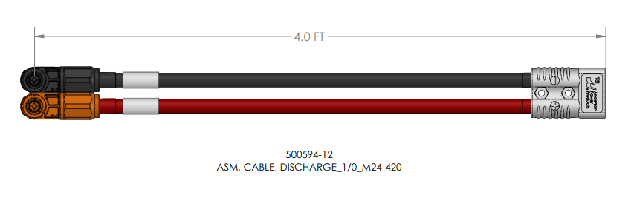

## Appendix A-20: POWER CABLES 2ft 1/0 AWG RED SERVICE KIT

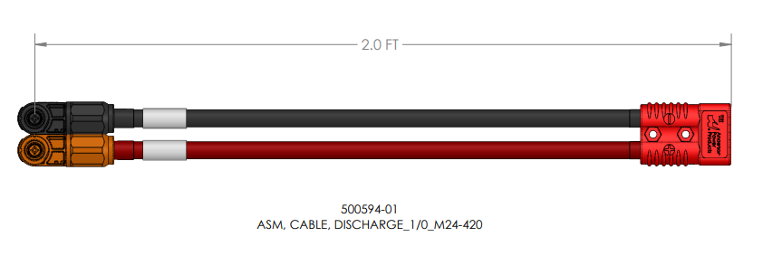

## Appendix A-21: POWER CABLES 3ft 1/0 AWG RED SERVICE KIT

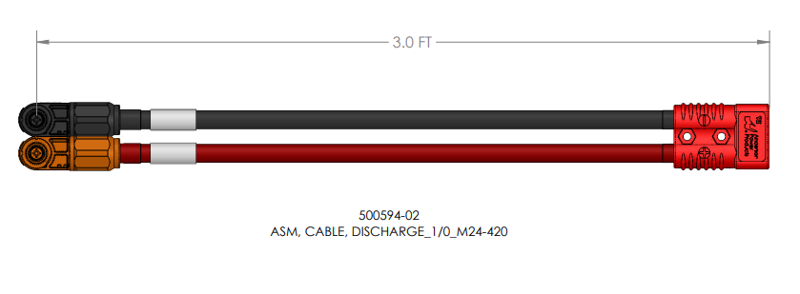

## Appendix A-22: POWER CABLES 4ft 1/0 AWG RED SERVICE KIT

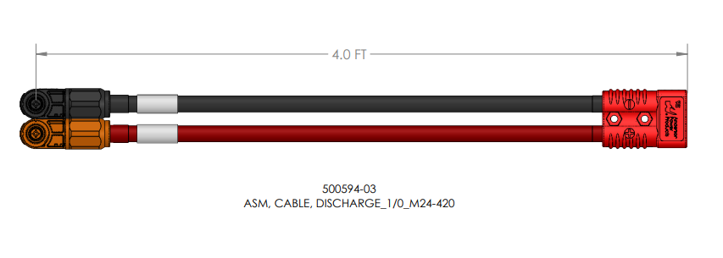

# Flux Power Contact Details

FLUX Power Inc.

Address: 2685 South Melrose Drive,

Vista, CA 92081

Tel: 877-505-3589

Fax: 760-741-3535

Email: [Support@fluxpower.com](mailto:Support@fluxpower.com)

Web: [www.fluxpower.com](http://www.fluxpower.com)

WARNING – Risk of Fire – No User Serviceable Parts

Copyright © 2018 Flux Power, Inc. All rights reserved. Flux Power, the Flux Power Logo and Flux Power LiFT Pack are registered trademarks or trademarks of Flux Power, Inc. All other brands and product names are trademarks or registered trademarks of their respective owners. This information is intended for the use of Flux Power customers only. Any other use without the express written consent of Flux Power, Inc. is strictly prohibited

11/25/20, 990845v1.0